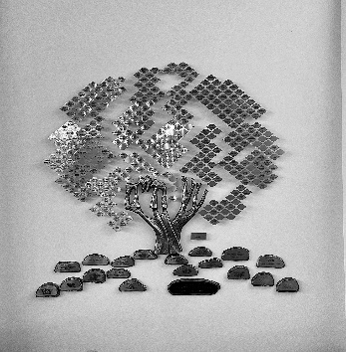
Congregation Bnai Zion
750 United Street Key West Florida 33040 305-294-3437
TREE OF LIFE ORDER FORM

I wish to inscribe _____________ Leaf /Leaves for $180.00 each
and/or _______________ Stone / Stones for $1500.00 Each
Please Print Clearly.. the words to be inscribed on the Leaf/Leaves or Stone/Stones
_________________________________________________________________________________________________________________________________________________________________________________________________________________________________________________________________________________________________________________________________________________________________________________________________
If more room is needed… use the back side of this form or staple attachment to form.
Please send your check and completed form to the Synagogue “Attn: Treasurer”

Your Name: ____________________________________________________________
Address: ________________________________________________________________
City / State / Zip: ________________________________________________________
Telephone: ______________________________________________________________
Email: __________________________________________________________________
Today’s Date: ____________________________________________________________

